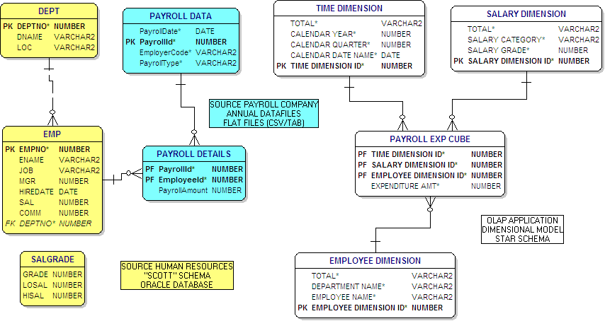
Interested in more OWB, consider doing the following:
- Look for an email about a new PSOUG Oracle Warehouse Builder course
- Visit http://www.bayontechnologies.com/bt/blog for information on how to set up the “demo environment” and also to read up on the upcoming release of OWB
- Visit the OWB page on OTN (http://www.oracle.com/technology/products/warehouse/index.html), rittman.net
- Email ngoodman@bayontechnologies.com for your own knowledge, or specific project work

